Welcome to a step by step guide on how to register for tournaments on Trackwrestling. Trackwrestling is the site we use to register for our tournaments. It contains a ton of information on current tournaments, past tournaments, results, and profiles of wrestlers. You will need to create an account the first time you register for a tournament. This process will create a Trackwrestling profile for your wrestler which he/she will use going forward. Once you have completed the initial registration and account setup, then registering for tournaments will be much easier and faster.
Please make sure you have purchased your AAU membership for the current season. It is required to register for any AAU tournament. If you have not already done so, then go here. Remember to choose the Extended (AB) Option.
This post contains a LOT of information. Please make sure to read it all.
The screenshots you will see are from the mobile version of the site. The desktop version is very similar.
This is a step by step guide. You can click here to open Trackwrestling in a new window and follow along. There is also a link at the end of the post if you prefer to read everything first.
Once on the homepage, you will click on Events.
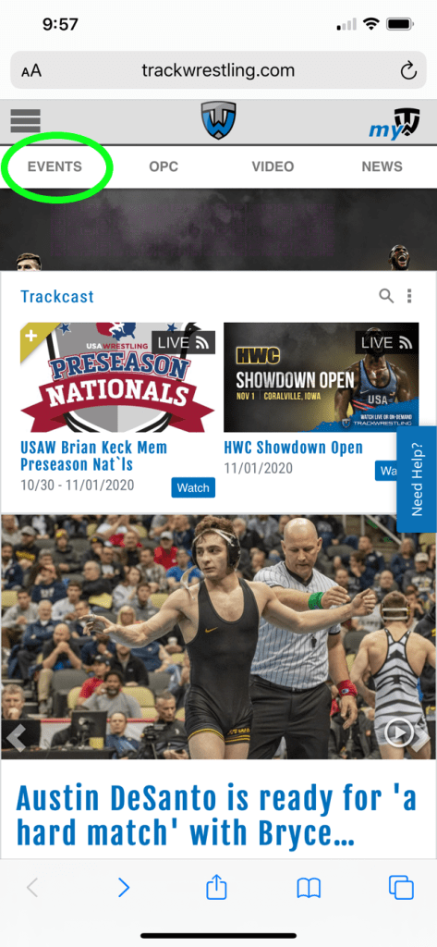

You will see a list of upcoming events. The easiest way to find the tournament you are looking for is by searching.
Click on the gear icon by Functions.

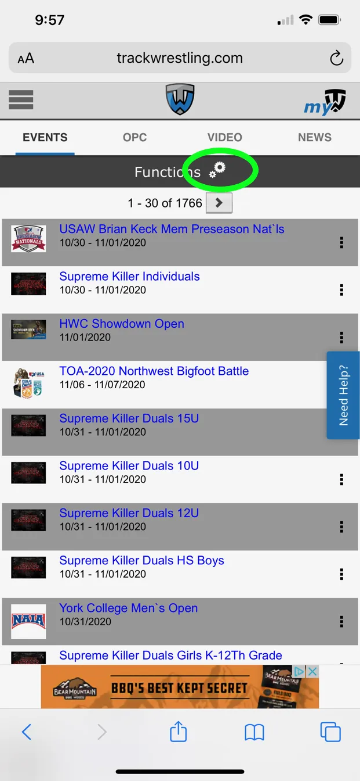

You will now see a Search Events bar that you need to click on.
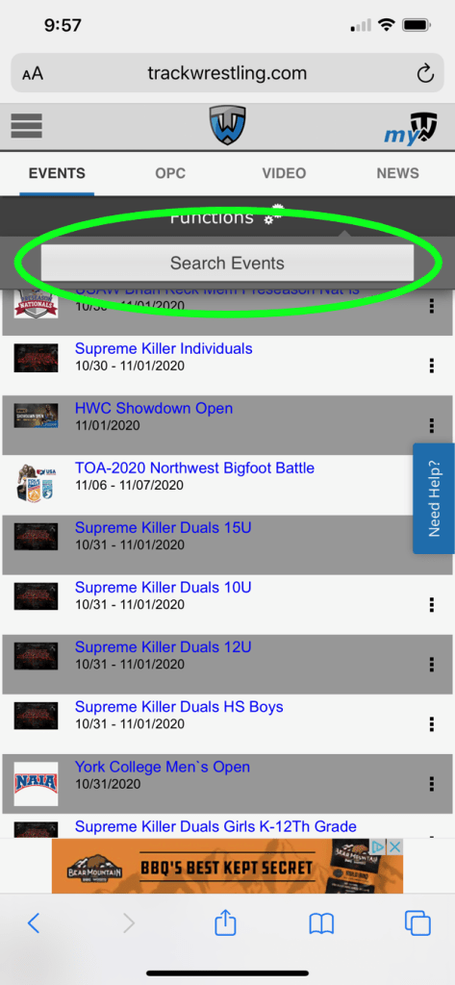

This page gives you the option to search for your tournament several different ways. You can use the name of the tournament if you know it. Other options are the date of the tournament as well the city and state it is being held in. Most of our tournaments are Alabama Youth Wrestling Organization tournaments and sanctioned by the AAU so they will have AYWO-AAU in the name. You can search by that and see a list of all AYWO-AAU tournaments that have been entered into Trackwrestling.

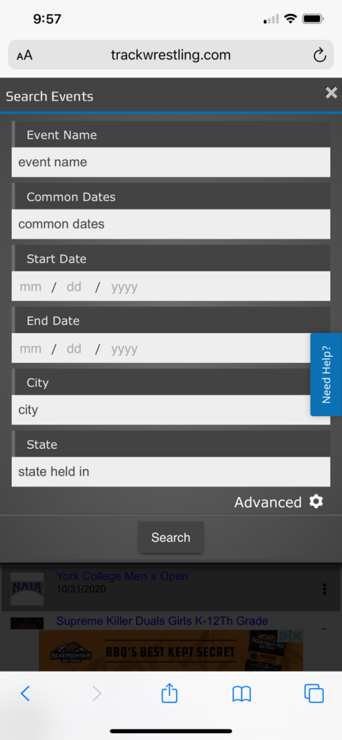

This is what you would see if searching only for AYWO in the event name field.
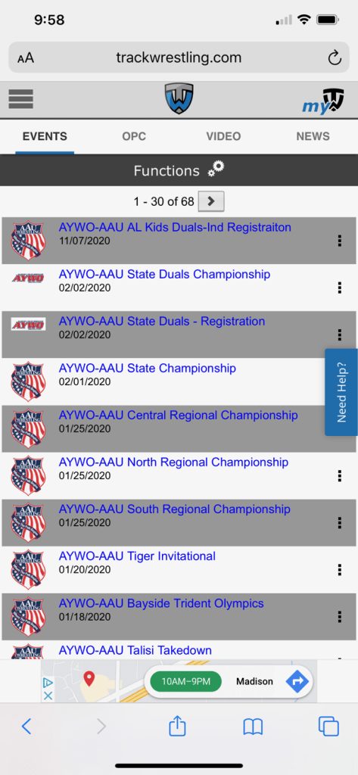

After clicking an event, you will be taken to the event landing page. Here, you must “enter” the event by clicking on the Enter Event button.
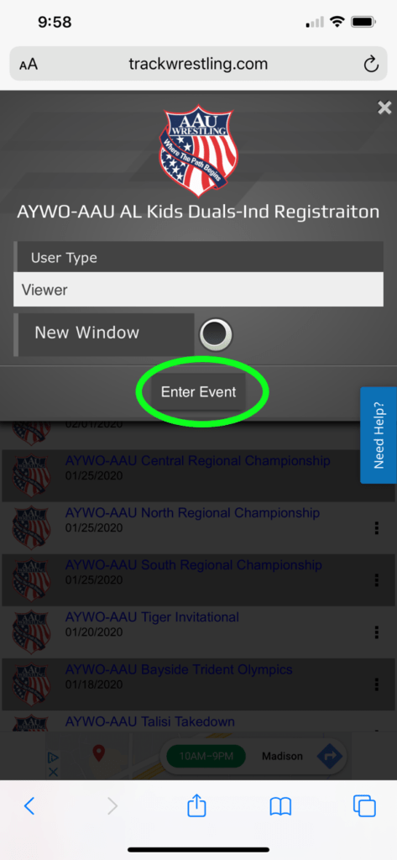

Once you are in the event, you will click on Registration to register for the tournament.
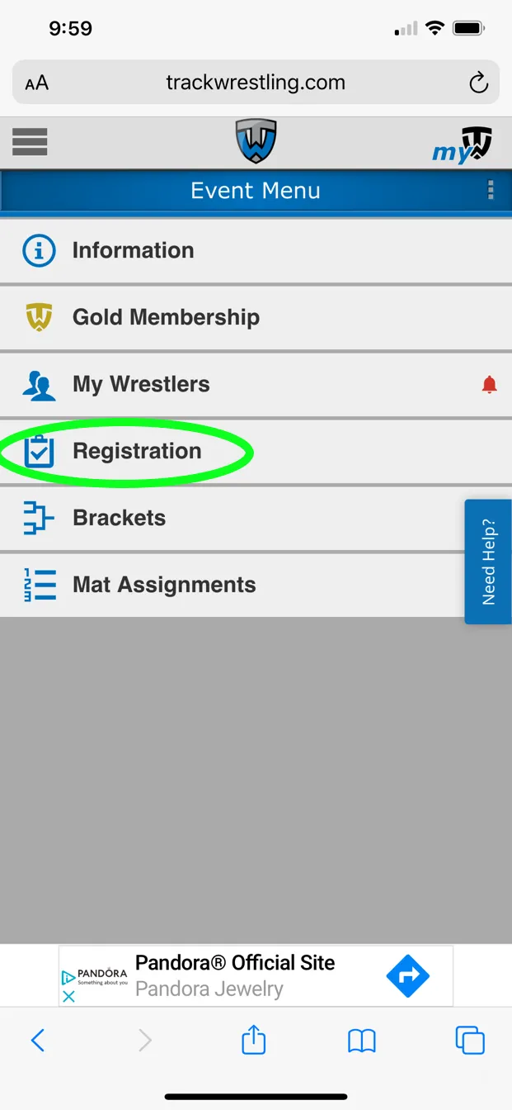

To create an account you will need to click on the link below the Sign In button. Creating an account makes the process of registering for additional tournaments in the future much faster.
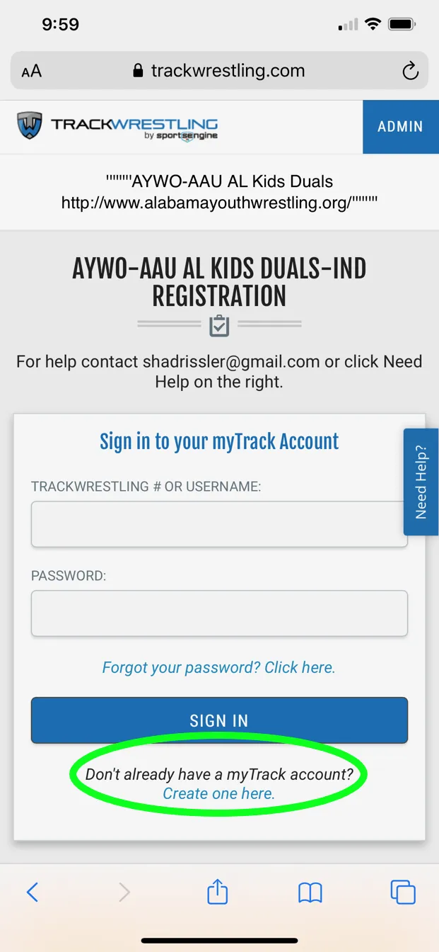

You will fill in YOUR information on the next screen. You will add your wrestler’s information later in the process.
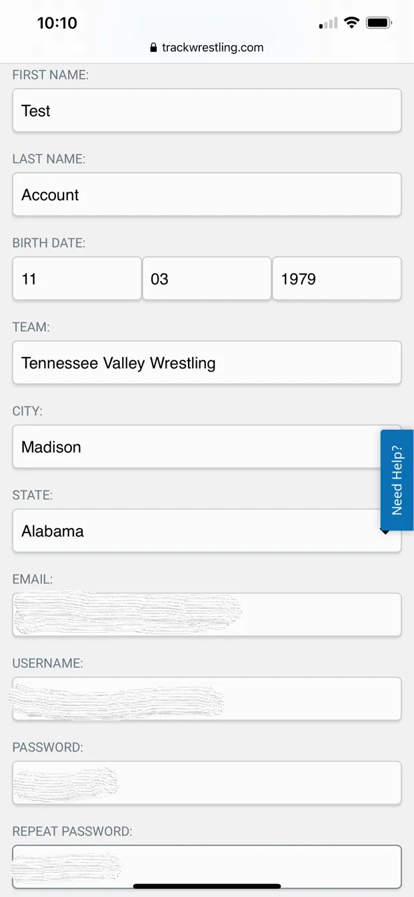

After filling in your information and clicking on the Create Account button, you will see the following screen. At this point you will begin the process of adding your wrestler.
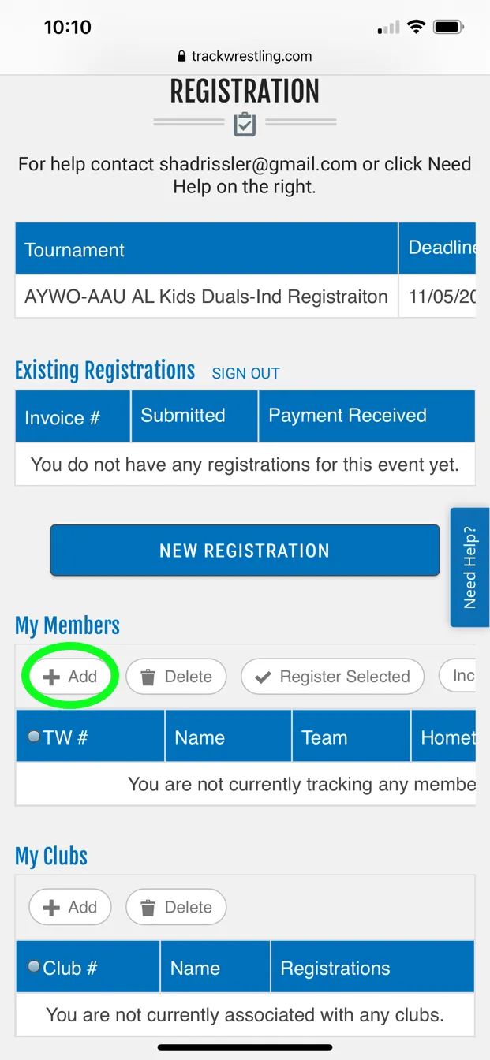

You will need to scroll to the bottom and click on the link to create a new account for your wrestler.
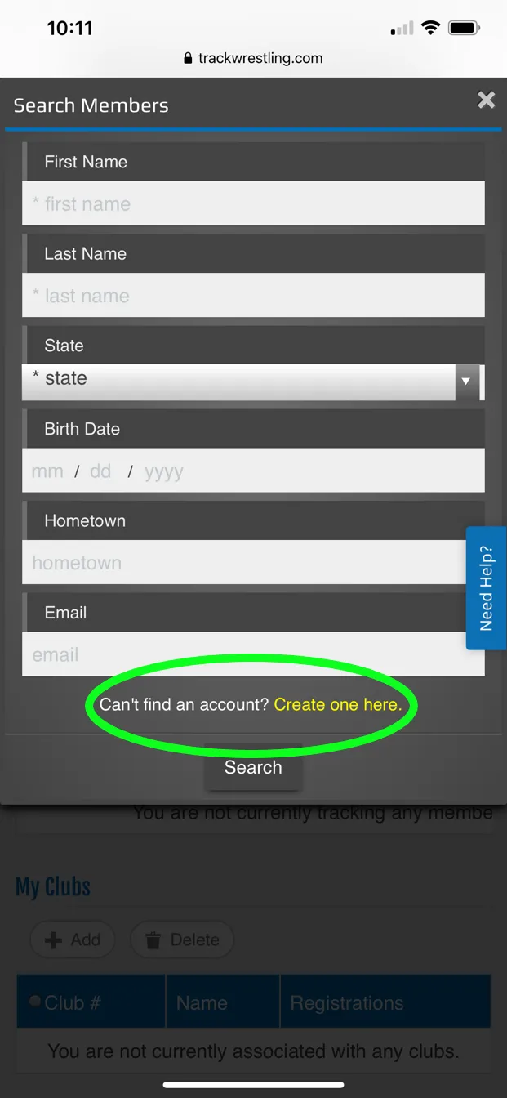

You will enter your wrestler’s name, birth date, team, city, state, and email address. Then click on the Create button. This will create their profile on Trackwrestling and assign them a Trackwrestling number.

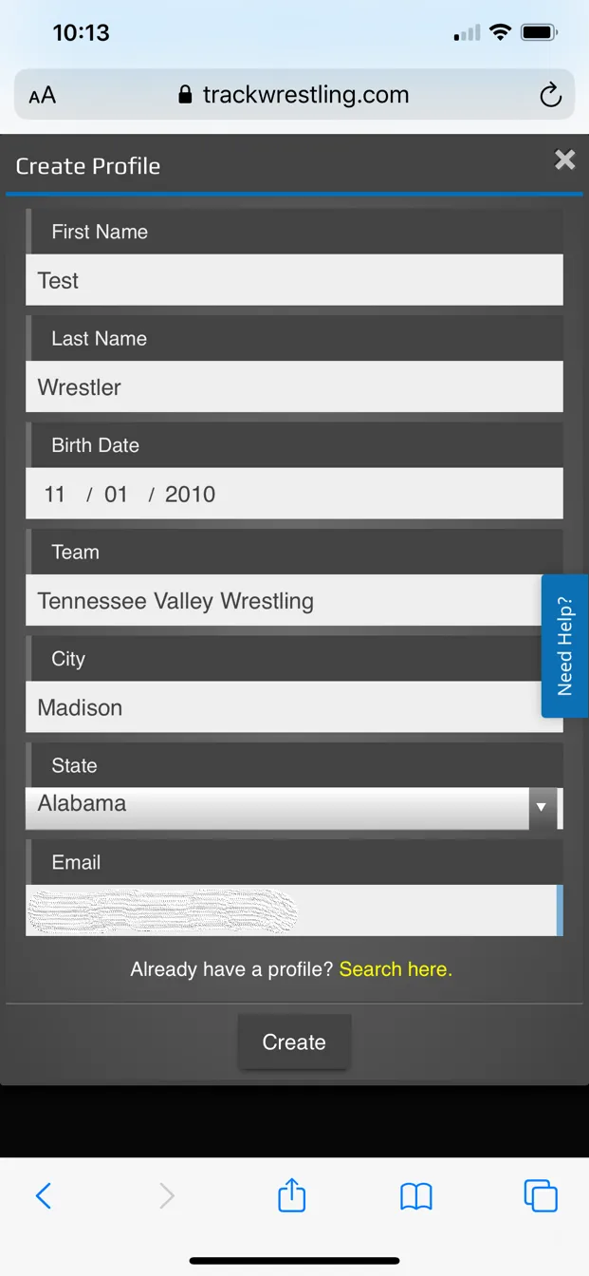

Once you have entered this information, you will be returned to the registration screen for the tournament. You will then make sure the wrestler is selected and then click on the Register Selected button to continue.
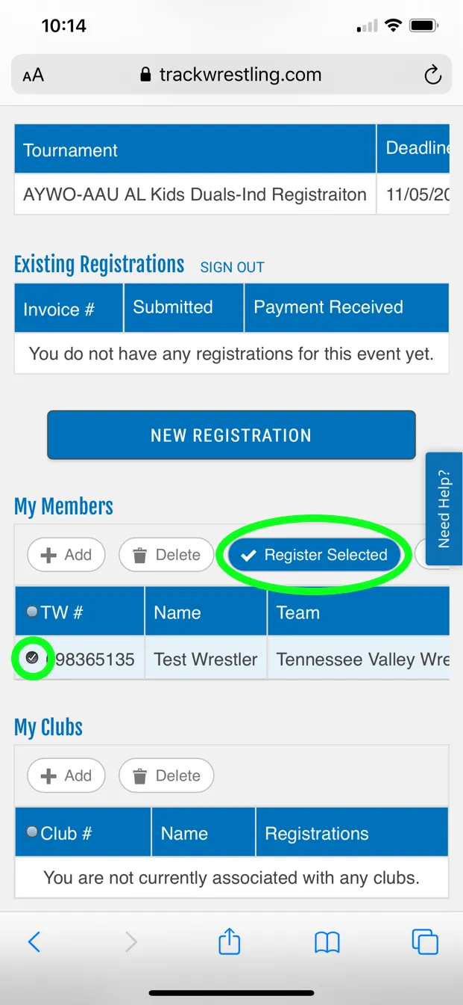

You should see your wrestler’s name, birthdate, team (Tennessee Valley Wrestling), city, state, and email address. You will then click on the Next button to continue.

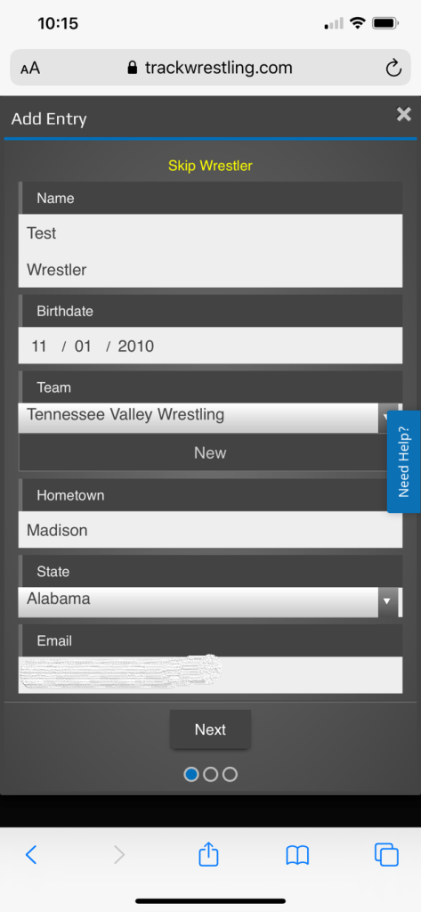

At this point, you must enter your wrestler’s AAU number. This number must be correct. If the number you enter does not match the birth date of your wrestler, then you will not be able to continue. The number below is only an example. AAU numbers contain letters and numbers. After entering the AAU ID, you can then select a grade and enter your wrestler’s record. Click the Next button to continue.
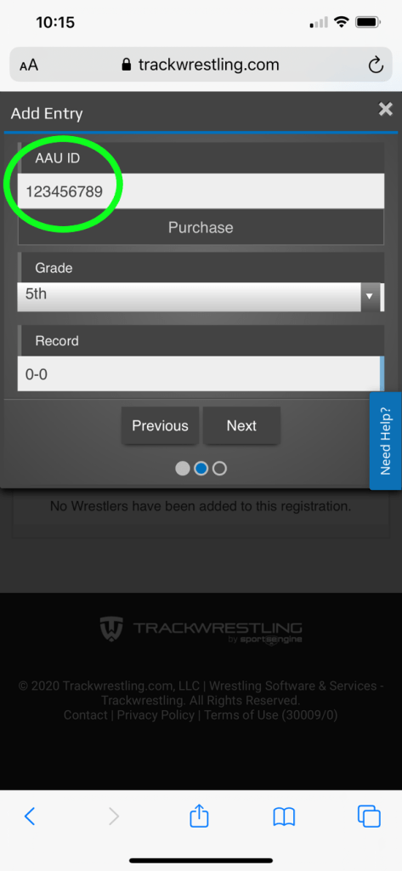

Once you have successfully entered the AAU ID, you will see the following screen. Make sure to select the checkbox for the tournament then click the Add Wrestler button to continue.
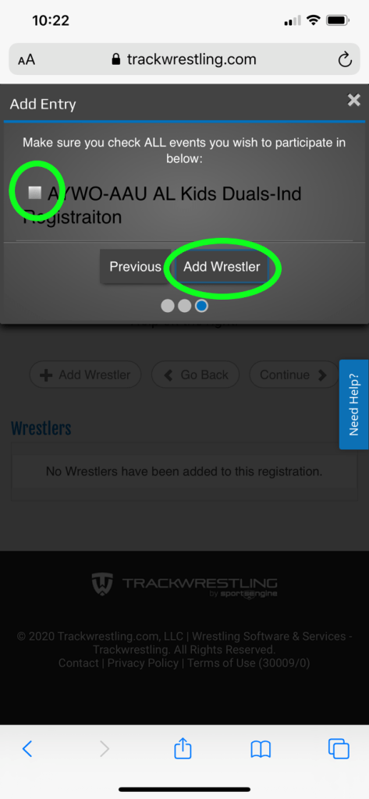

You will then be prompted to select a Division, Weight Class, and Separation Criteria for your wrestler. Click on Add Wrestler to continue.

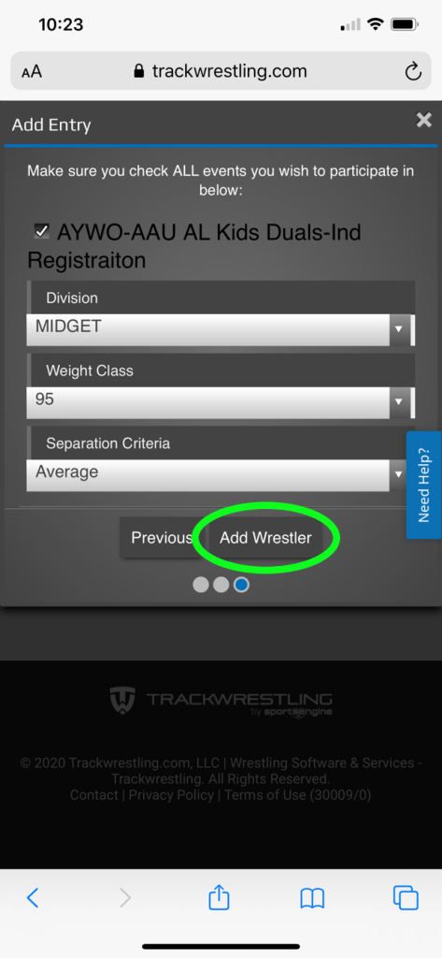

You will now see a summary screen. You can add an additional wrestler if needed by clicking Add Another Wrestler. If you do not need to add another, then scroll down to the bottom of the page.
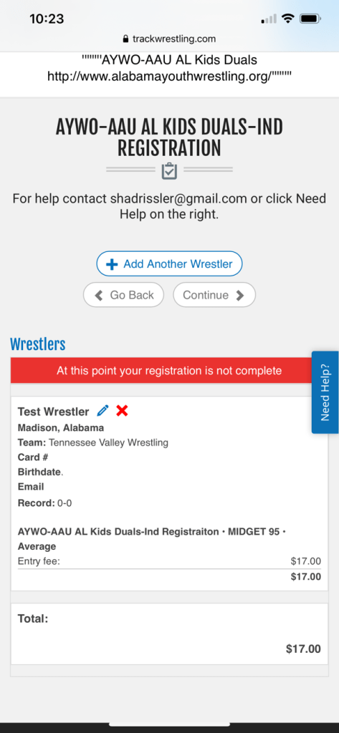

You have the option to purchase a Gold or Gold plus membership or just continue to the checkout process by clicking the Checkout button.
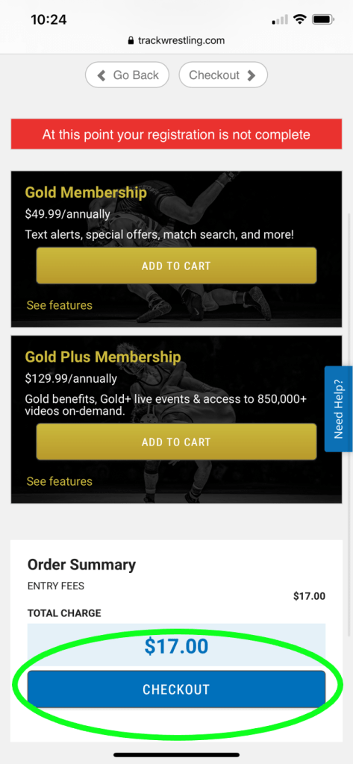

You will fill in your billing information. Both day and night phone numbers are required.
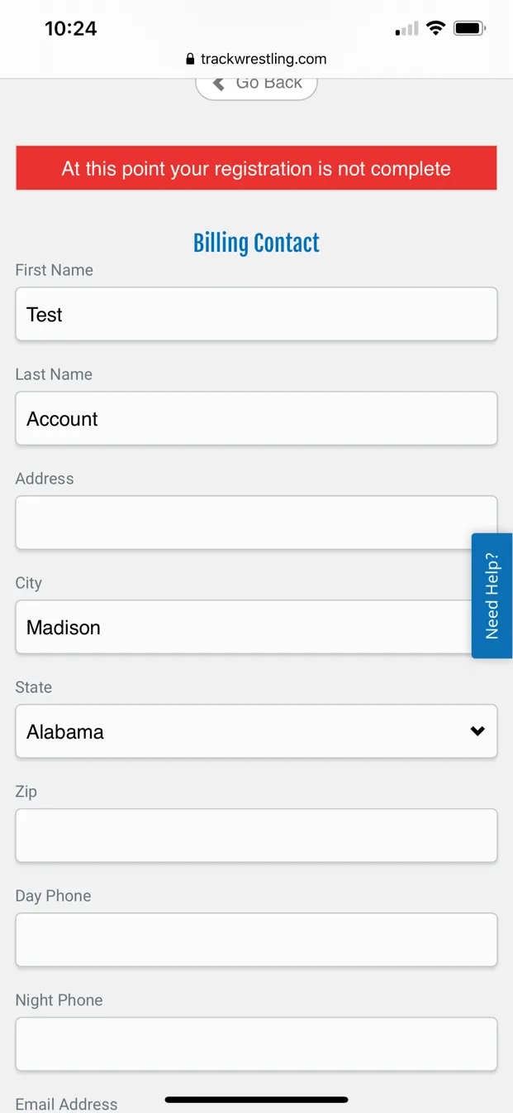

After filling in all the information, be sure to agree to the waiver and refund policies and select your payment method. Click Continue to proceed to the payment page.
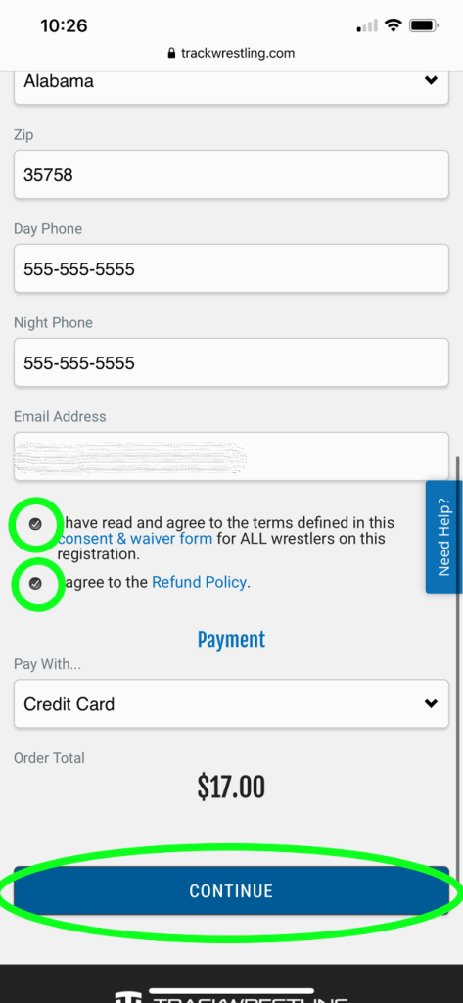

Enter your chosen payment information and click on the Pay button to finish.
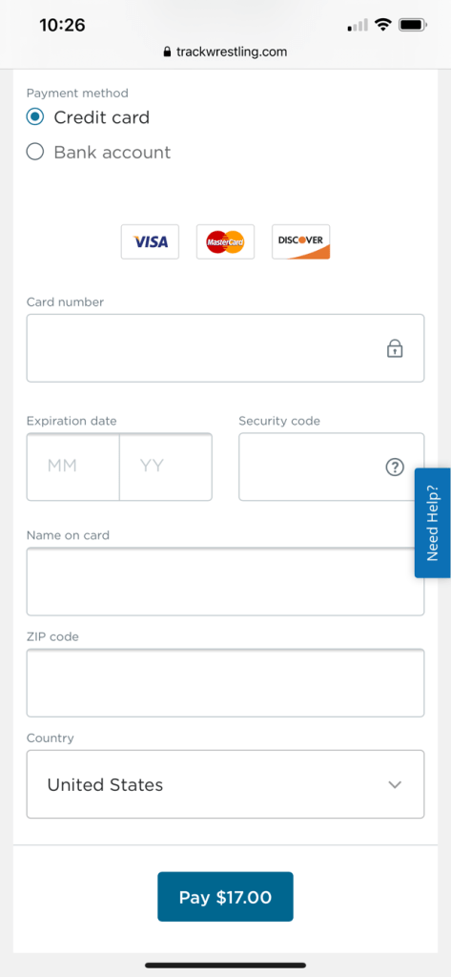
You can click here to get to the Trackwrestling site.
Congratulations! You have now created an account on Trackwrestling and registered for your first tournament. By creating the account, the registration process for any additional tournaments will be faster.
We will be adding a Trackwrestling navigation guide soon that will explain some of the tournament day features such as mat schedules, results, etc. As always, if you have any questions, reach out in the Facebook group, ask a coach, or send us an email at info@tennesseevalleywrestling.com

